**CSC8502 Coursework Scene Document**

**Screenshots**

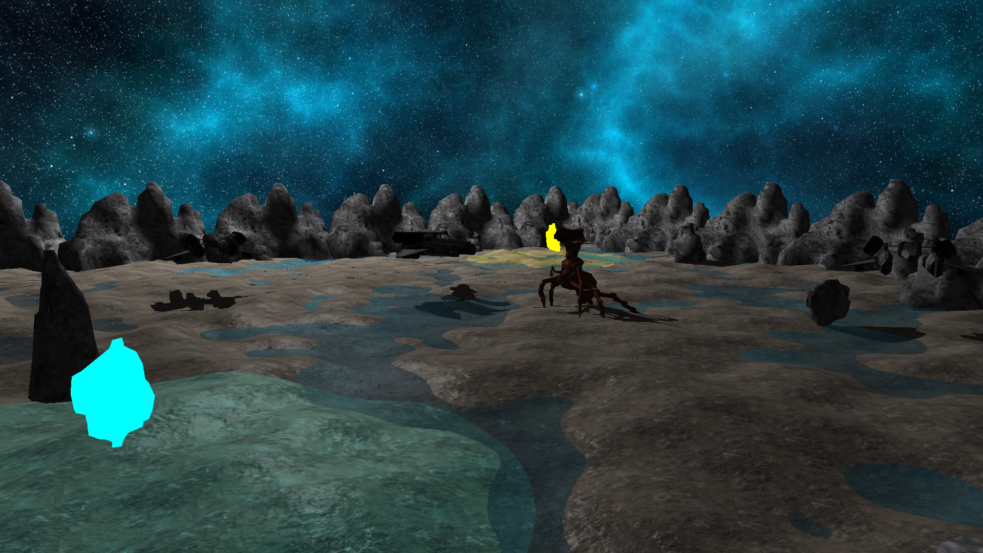

The scene contains a landscape as well as multiple meshes and textures, including a skeletally animated crab character, all rendered using a scene graph. There is a space skybox, and a water shader which provides environment mapping reflections of the skybox. All meshes generate real-time shadows based on the position of the sun, which orbits the scene and provides light as part of a day/night cycle. There are additional point lights which contribute to the scene lighting using forward shading. Below you can see the scene at night.

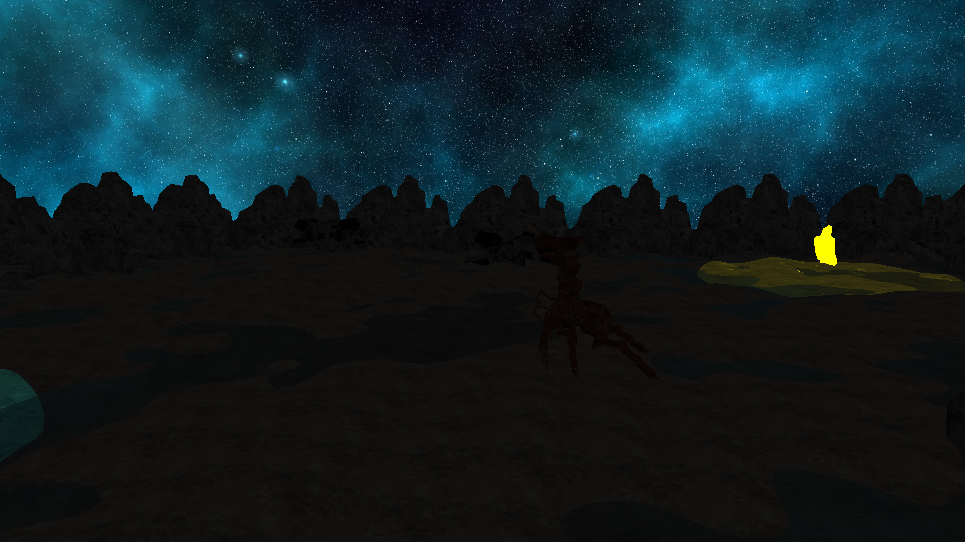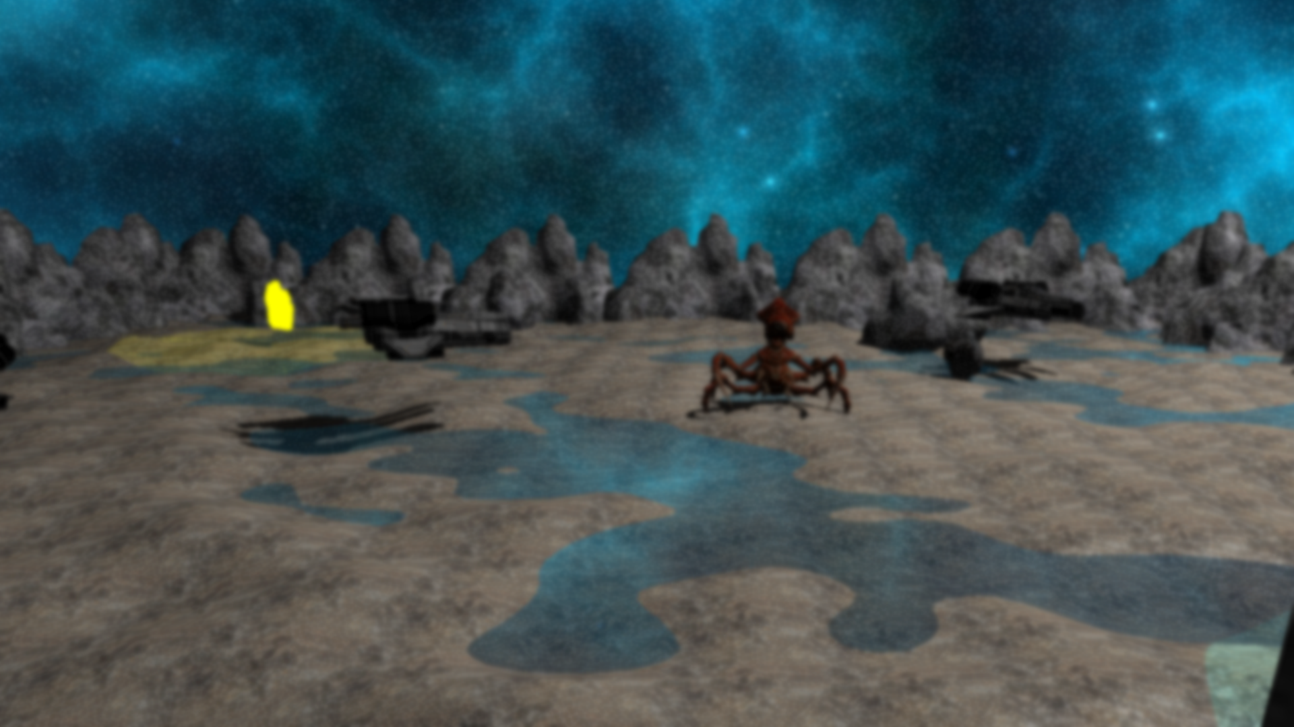

Multiple post processing effects were implemented – blur (above), bloom (below), and a ‘night vision’ effect which brightens the scene and tints it green. The blur and bloom effects use the same Gaussian blur technique; for bloom the bright areas of the frame are extracted and only these are blurred to create a glowing visual effect.

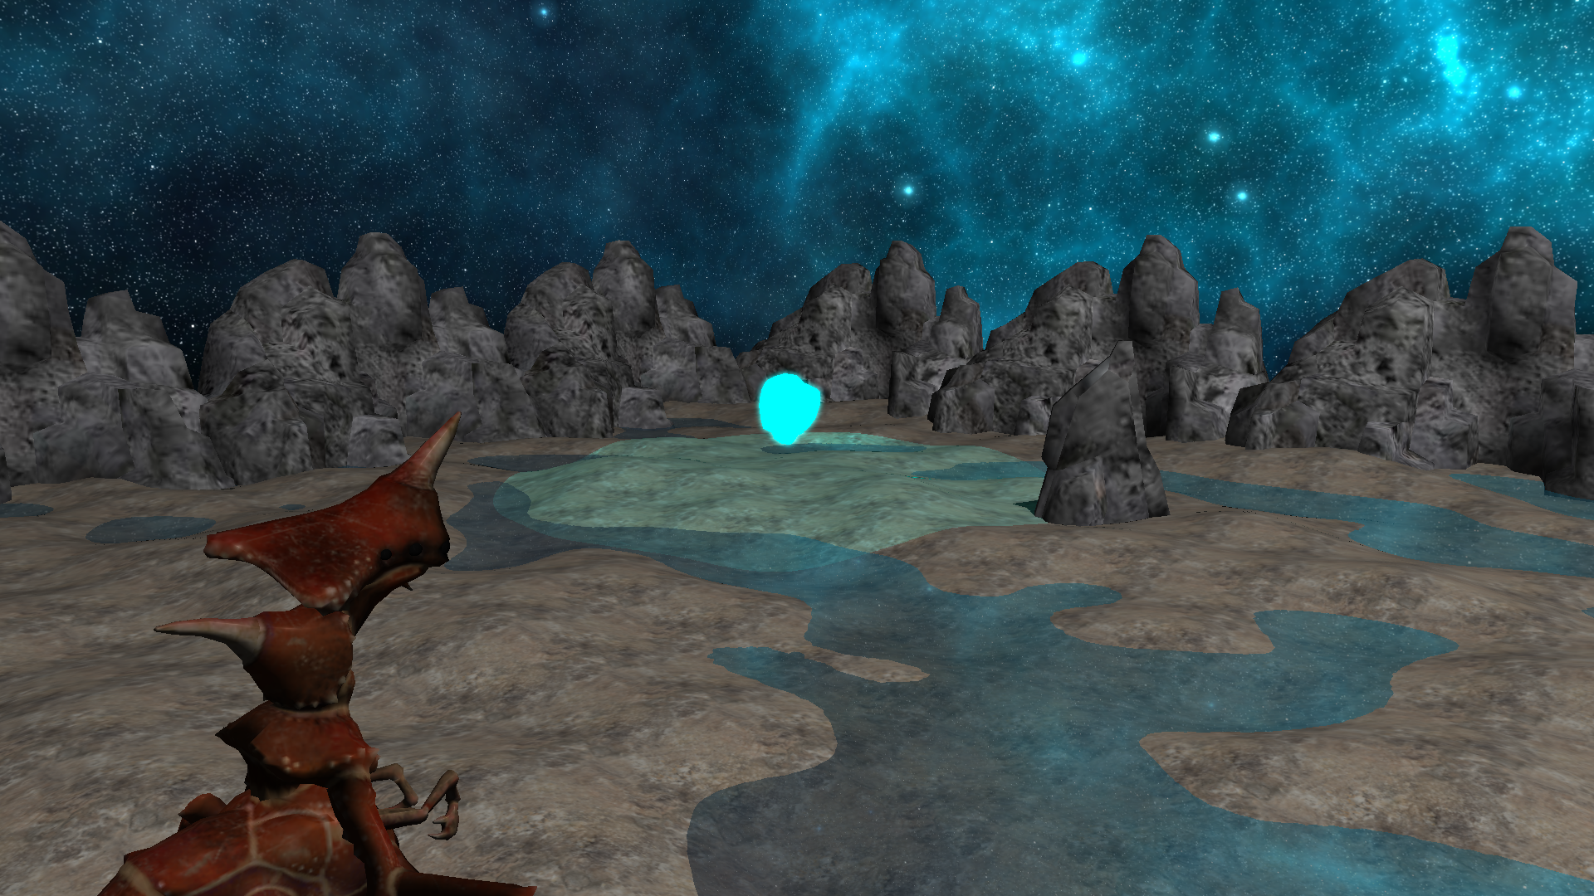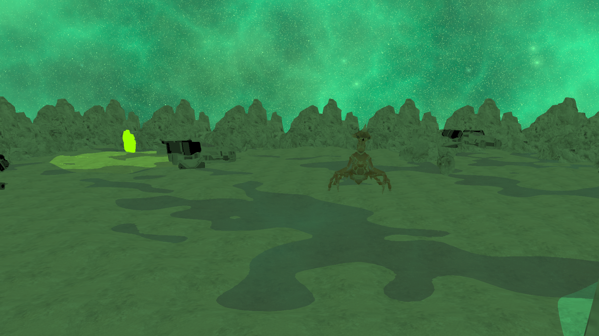

The ‘night vision’ effect was created within a fragment shader by applying a high gamma value to brighten the scene, and by scaling down the red and blue colour channels to tint the frame green.

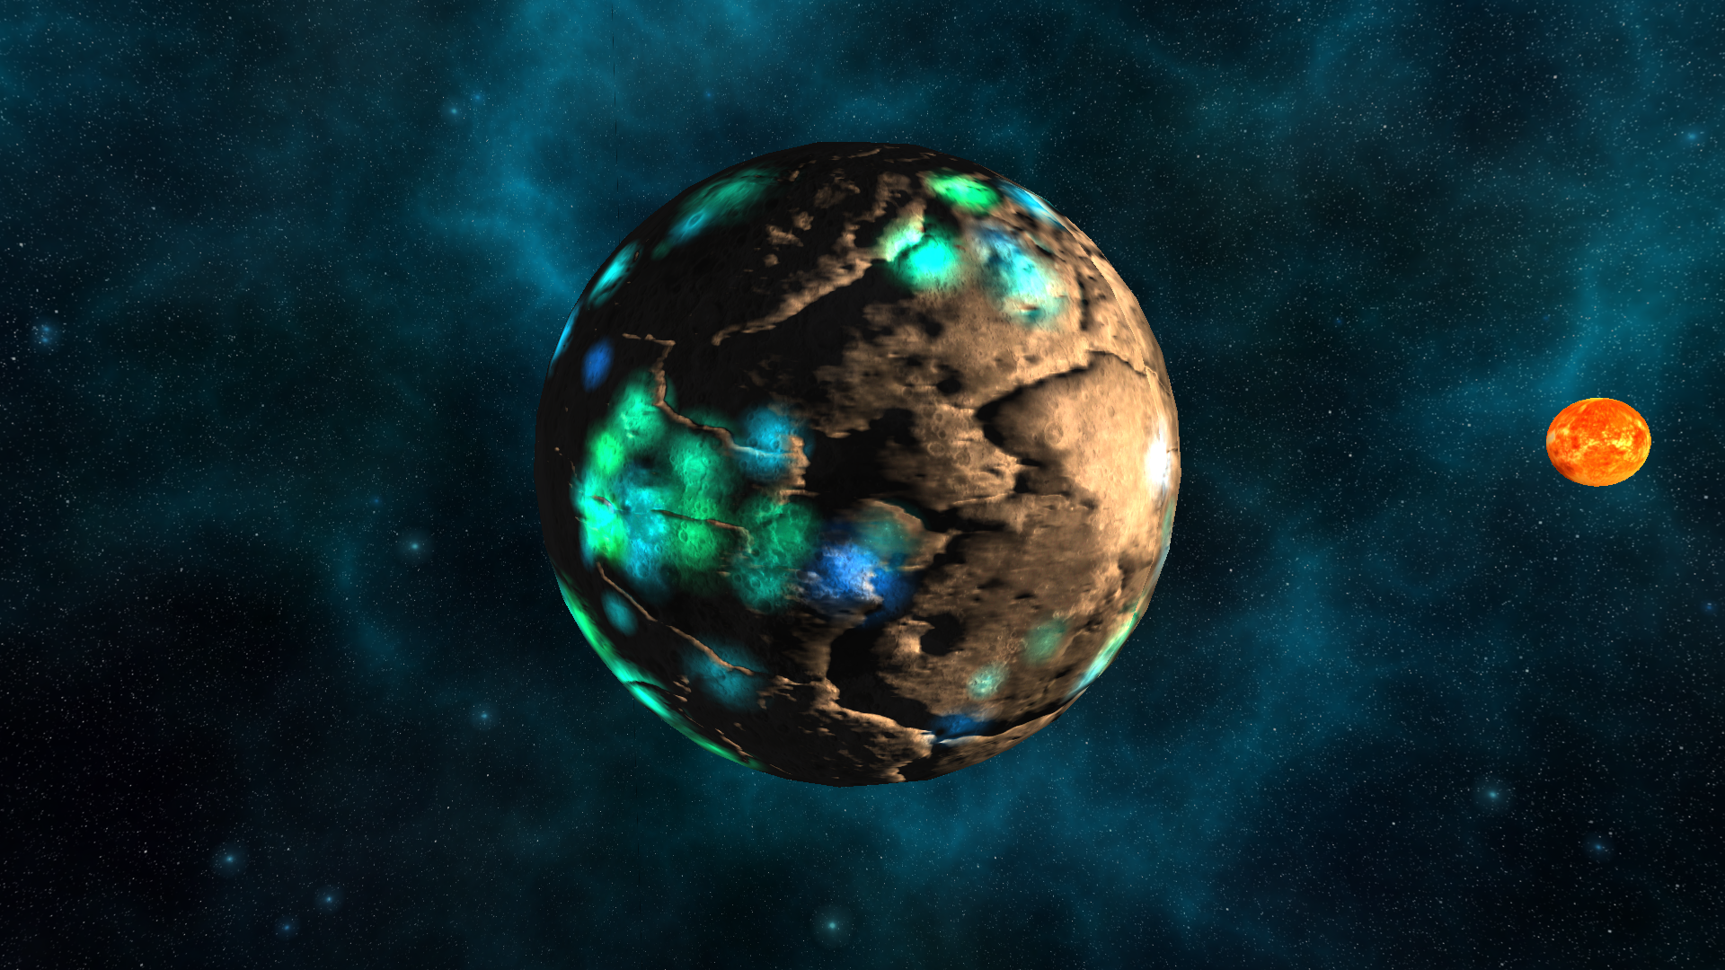

By pressing ‘Z’ you can transition to a view of the planet from space, which is lit using deferred rendering of multiple point lights – lights on the surface move and glow, while the sun orbits the planet and also contributes to the lighting.

**Key Binds**

* WASD - move camera
* Shift, Space - move camera up/down
* C - restart automatic camera track
* V - manual camera control
* Z - switch to/from space scene
* P - enable bloom
* O - enable blur
* I - disable bloom/blur
* N - toggle night vision on/off

**Youtube Video Link**

<https://youtu.be/P9bqlQVvOtg>

**Unity Assets Used**

* Free Rocks asset pack by Triplebrick - <https://assetstore.unity.com/packages/3d/environments/landscapes/free-rocks-19288>
* Insectoid Crab Monster by LB3D - <https://assetstore.unity.com/packages/3d/characters/insectoid-crab-monster-lurker-of-the-shores-20-animations-107223>
* Hi-Rez Sci-Fi Spaceships Creator Free Sample by Ebal Studios - <https://assetstore.unity.com/packages/3d/vehicles/space/hi-rez-sci-fi-spaceships-creator-free-sample-153363>
* Heightmap Generator by Manuel Iuliani - <https://assetstore.unity.com/packages/tools/modeling/heightmap-generator-260294>

**Textures Used**

* Sun and moon textures from <https://www.solarsystemscope.com/textures/>
* Space skybox from <https://opengameart.org/content/space-skyboxes-0>
* Terrain texture from <https://polyhaven.com/a/rock_boulder_dry>
* Terrain texture from <https://www.manytextures.com/texture/272/muddy-terrain/>